**Tempus – Coding Challenge: RNA Internship**

1. Question 1 – Outlier Removal and Differential Expression Analysis
   1. Removing Low-Count Genes

First, genes with low CPM (counts per million) values were identified (a threshold of CPM >=1 was applied). Ideally, I would remove genes which crossed the threshold CPM in at least a third of the samples were identified. However, since out of 51 out of the 152 samples belong to one group, this strategy would skew out analysis. Instead, I chose to retain genes which crossed the threshold CPM in at least 30 samples.

* 1. Removing Outlier Samples

Next, a correlation matrix which calculated the Pearson-correlation distance for the samples was generated. Pearson-correlation was preferred over other methods since it gives information about the tendency of two vectors (samples) to increase/decrease together. This is useful for outlier removal since we want to find samples which might cluster incorrectly within groups.

The Hclust function was used to cluster samples according to Pearson distance (1-Pearson correlation). Complete linkage clustering, which treats each sample as an individual cluster, and successively adds new elements was chosen. The cluster dendrogram was analyzed and samples which were identified to cluster incorrectly within groups were removed.



*Fig 1 – Cluster Dendrogram showing two outlier samples identified*

After manual inspection of the dendrogram, 8 samples were observed to cluster incorrectly and were removed: cancer8, cancer58, cancer87, cancer98, cancer100, normal27, normal34, normal.

1. Question 2 - Differential Gene Expression

For differential expression analysis, the edgeR package was used. The counts matrix was stored as a DGEList. The dispersion of gene counts was estimated using negative binomial distribution. Then, the sample-wise dispersion along with the common dispersion and trended dispersion was plotted. I observed that the trended dispersion did not correlate with the tagwise(sample-wise) dispersion, and therefore decided against using a Linear Mixed Model to go forward with the gene expression analysis. Instead, Fischer’s Exact Test was used to estimate dispersion between the two sample groups.



*Fig 2 – Dispersion trends for dataset. Trend of dispersion is not strong enough to justify use of LMMs*

After finding the differentially expressed genes, Benjamini-Hotchberg/FDR correction was applied and points the differentially expressed genes were to be found as follows:



1. Question 3 - Identification of Tumor Type

The give tumor samples belong to breast cancer patients. The genes TYRO3, PLA2G4C, ZBT333 and GATA6 are significantly upregulated in our dataset. These have been implicated as markers of breast cancer in literature as well.

1. Question 4 - Identification of Tumor Subtype

Before tumor subtyping, data was normalized using RLE (Relative Log Expression), other methods (TMM, upperquartile) were tested, however RLE gave the best results and thus was selected.





*Fig 3 – Variation of logCPM values before and after normalization of counts*

Subsequently, logCPM counts for the samples are calculated and a Pearson correlation matrix is created for the tumor samples. MDS plots, hierarchical clustering plots and PAM (partitioning around medioids) are carried out using a Pearson distance matrix. Analysis of these plots shows that the tumor samples can be clustered into two subtypes.



*Fig 4 – Dendrogram for tumor samples shows two clusters (one large and one small)*

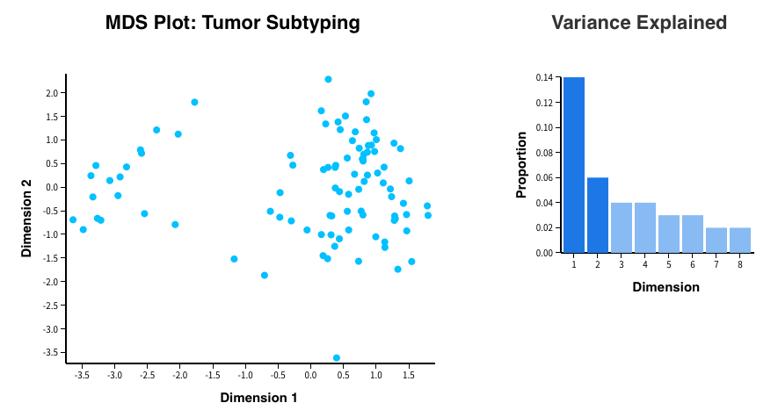

*Fig 5 – MDS for tumor samples shows two clusters (one large and one small) as well*

**

*Fig 6 – PAM clusters for tumor samples shows two clusters (one large and one small) as well. Additional bootstrapping was carried out to confirm significance of cluster discovery*

1. Question 5 – Number of Additional Samples Required

The number of samples required to find one more tumor subtype is highly dependent on the nature of the samples being added to the cohort and their relative distance to the other samples. I calculated the standard deviation for each of the groups to gain information about within-group variation. The standard deviation for subtype 1: 0.0352, and the standard deviation for subtype 2: 0.0651. The overall standard deviation for the group of tumor samples: 0.051

I randomly selected n items from subtype 1(n-> 8:70) and added them to samples from subtype 2 to see how many elements from subtype 1 would be needed for stable clusters of subtype 1 and subtype 2 to be formed. I repeated this process multiple times to determine an addition size which would lead to the formation of 2 clusters.



*Fig 7 – Number of PAM clusters formed by incremental & iterative random sampling of tumor subtype 1*

It was observed that by taking 20 samples at random from group 1, stable clusters were almost always formed (11/12 times). However, this method of estimation is not too reliable since the formation of a new subtype would be highly dependent on the expression profile of the incoming samples.

For example, if two samples which have distances from medoids (cluster centers) more than the standard deviation of that group, a new cluster would be formed immediately. However, if a sample would be closer to one of the clusters already present, depending on the nature of the sample, a new cluster might be formed by adding 8-20 samples.